Nama : Nayottama Satya Hutama

NIM : 18090004

Kelas : 5C

PRAKTIKUM 6

1. Source code

Bootstrap.php => controller

v_bootstrap.php => View

ModelBuku.php => model

ModelUser.php => model

1. URL

<http://localhost/Pustaka_Booking_Nayottama/Bootstrap>

1. Capture Output Program

Bootstrap.php

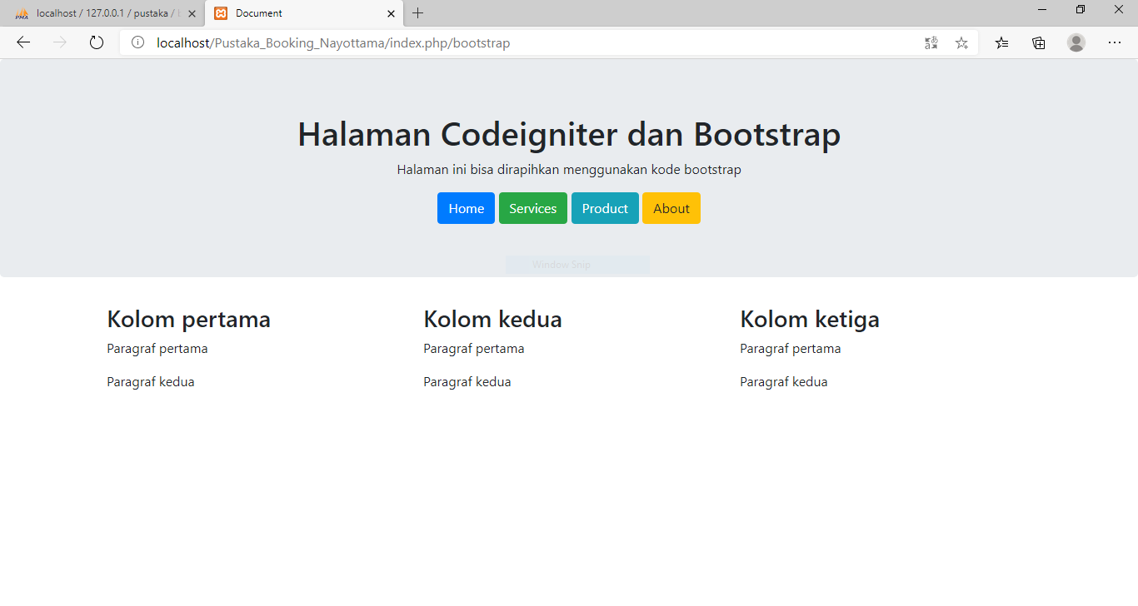

Database tabel user

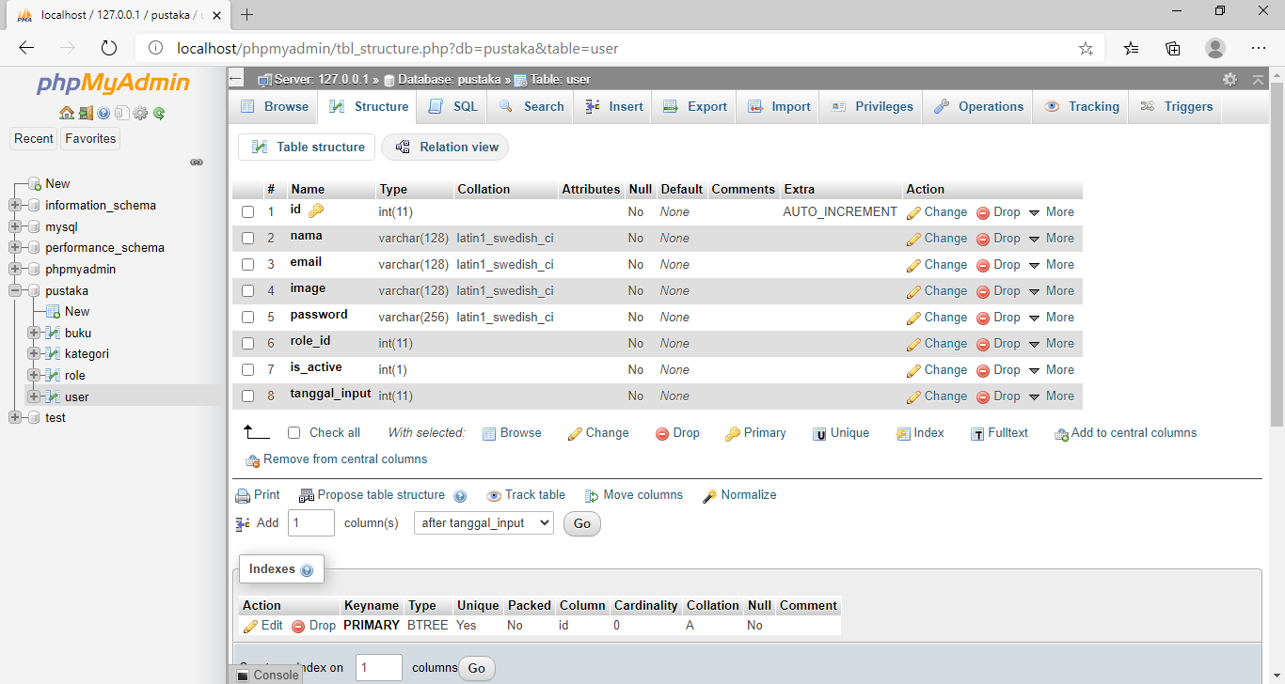

Database tabel kategori

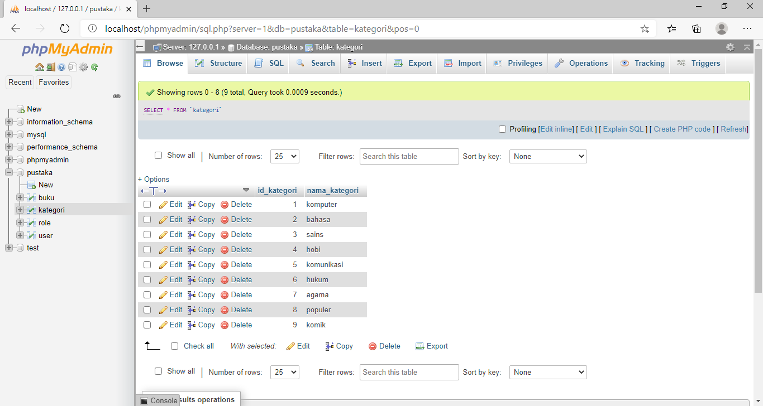

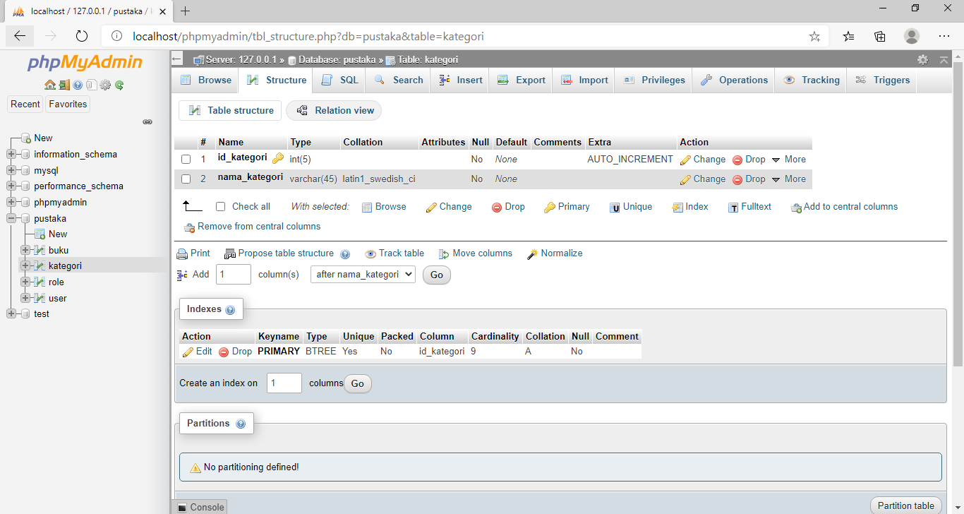

Database tabel role

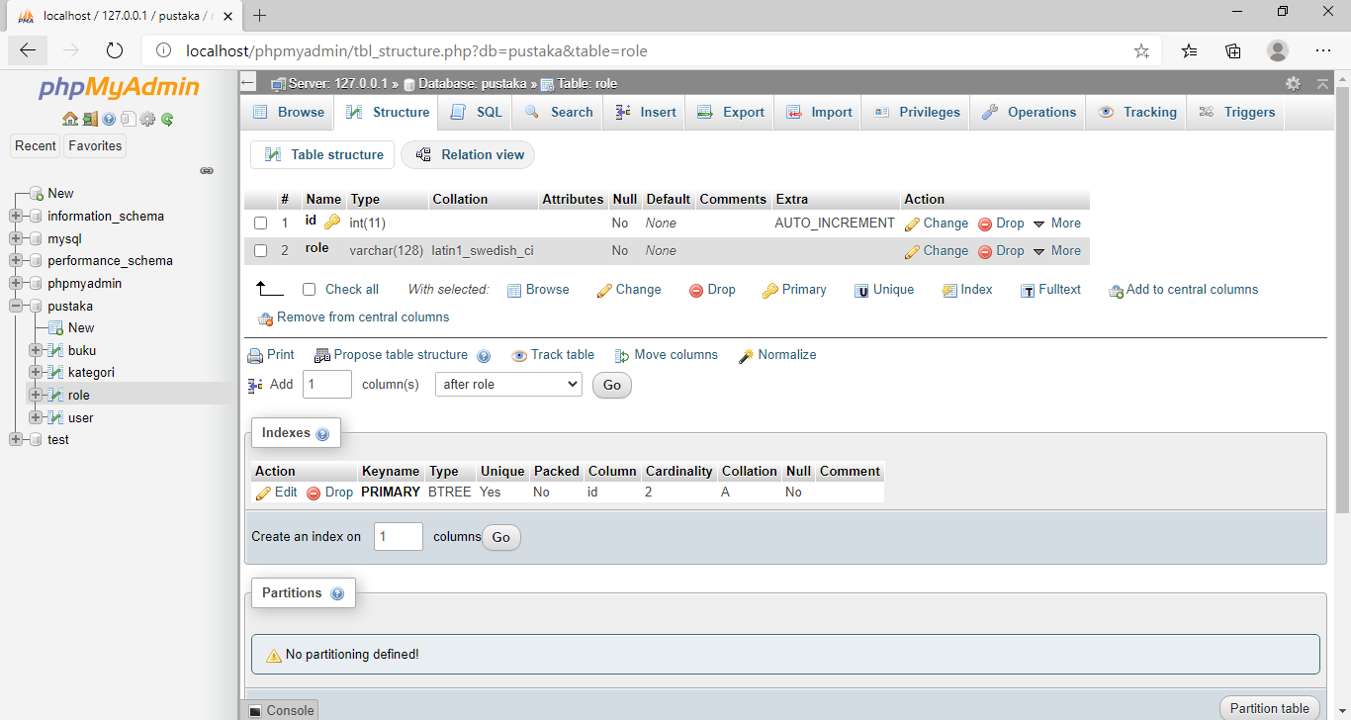

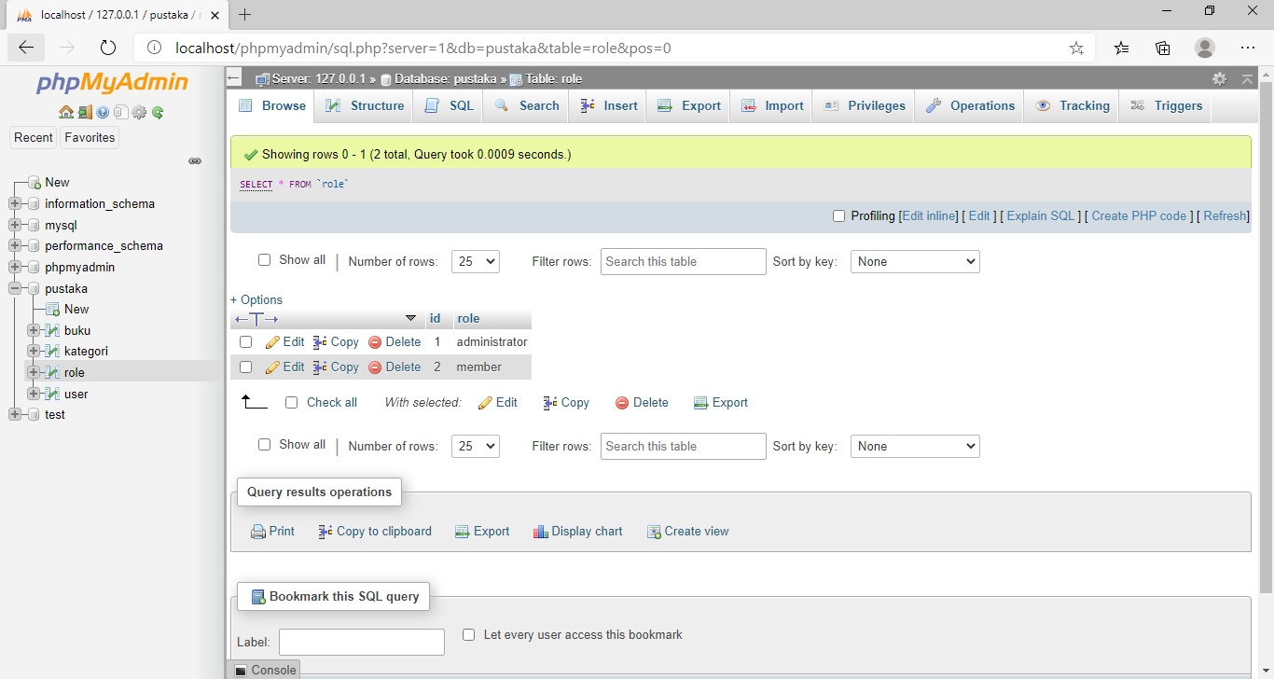

Database tabel buku

